OMS Library Digital Orientation – Step 2
Fiction eBook Access – AXIS 360

Hello, this is Mrs. Harmon, and I am going to give you a quick tutorial of how to get to (fiction) ebooks (Axis 360) through the library catalog.

Contact information: Mrs. Harmon, Librarian
karen.harmon@pisd.edu
Library Telephone: 469.752.8527

Begin on your webdesk. You want to find the PISD Library Koha-Catalog app, this green one, and click on it. If you decide not to access it this way, you can type catalog.pisd.edu into your search bar.

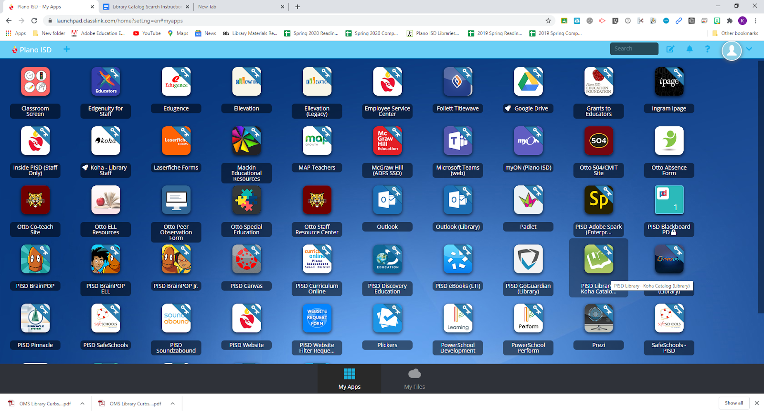

When you enter the catalog from your webdesk it may automatically sign you in, which is great! But if it doesn’t, or you enter by typing catalog.pisd.edu in the search bar, you do not need to login at this time to access ebooks. You will need to do that later, whether you login now, or not.

Since we are looking for eBooks, we need to click on the “Middle School Lib. Resources” link (see below).

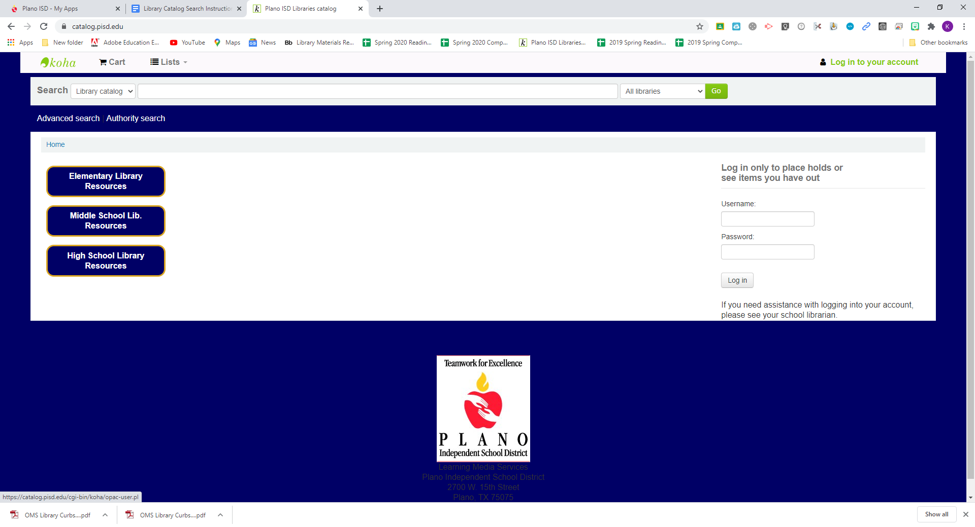

You will then see this screen and want to choose EBOOKS. There are two places to click and access them, see below:
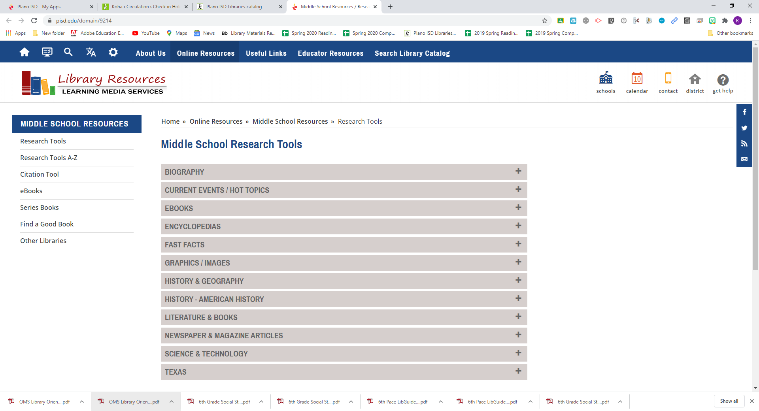

You can click on either link. Then click on “eBooks from Axis 360 (fiction)”.

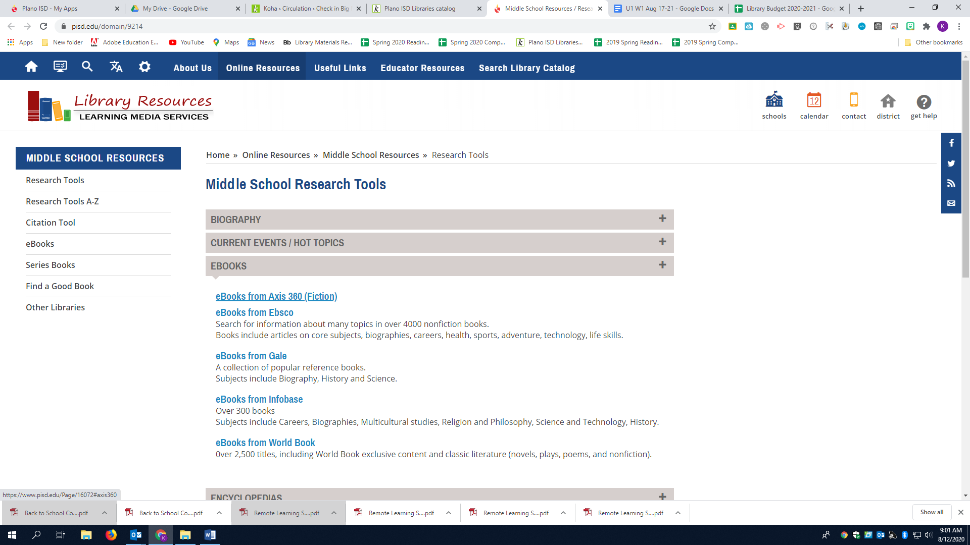

You may download an app on your smartphone. There are instructions for Apple Devices and Android Devices. Please do so if you’re interested in accessing it on your mobile device (see below).

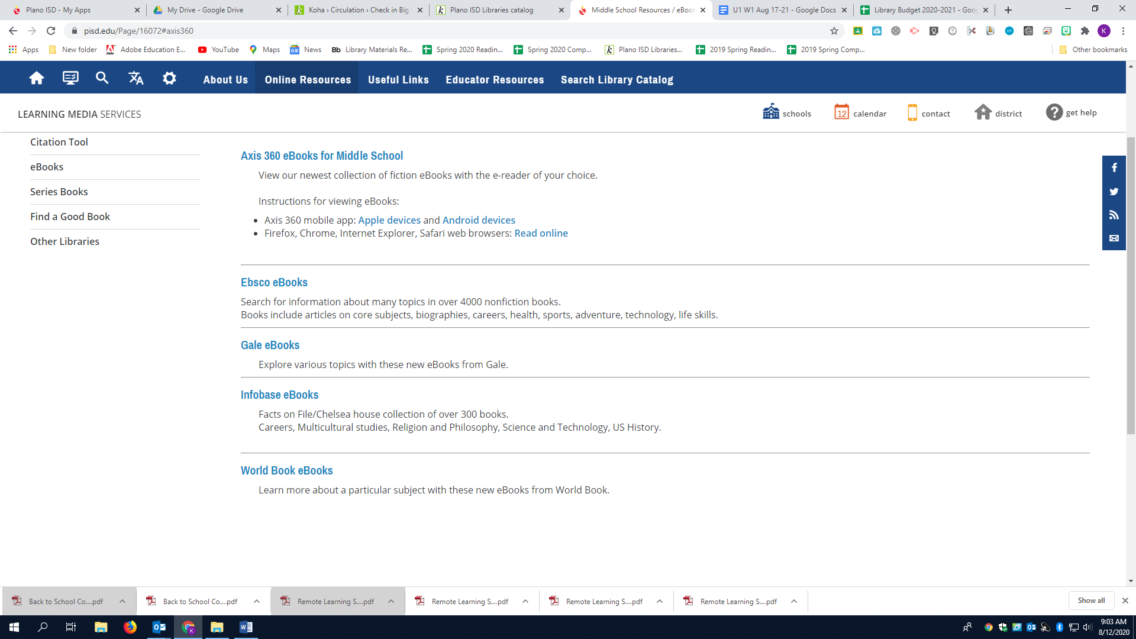

Click on “Axis 360 eBooks for Middle School” and this is what you will see:

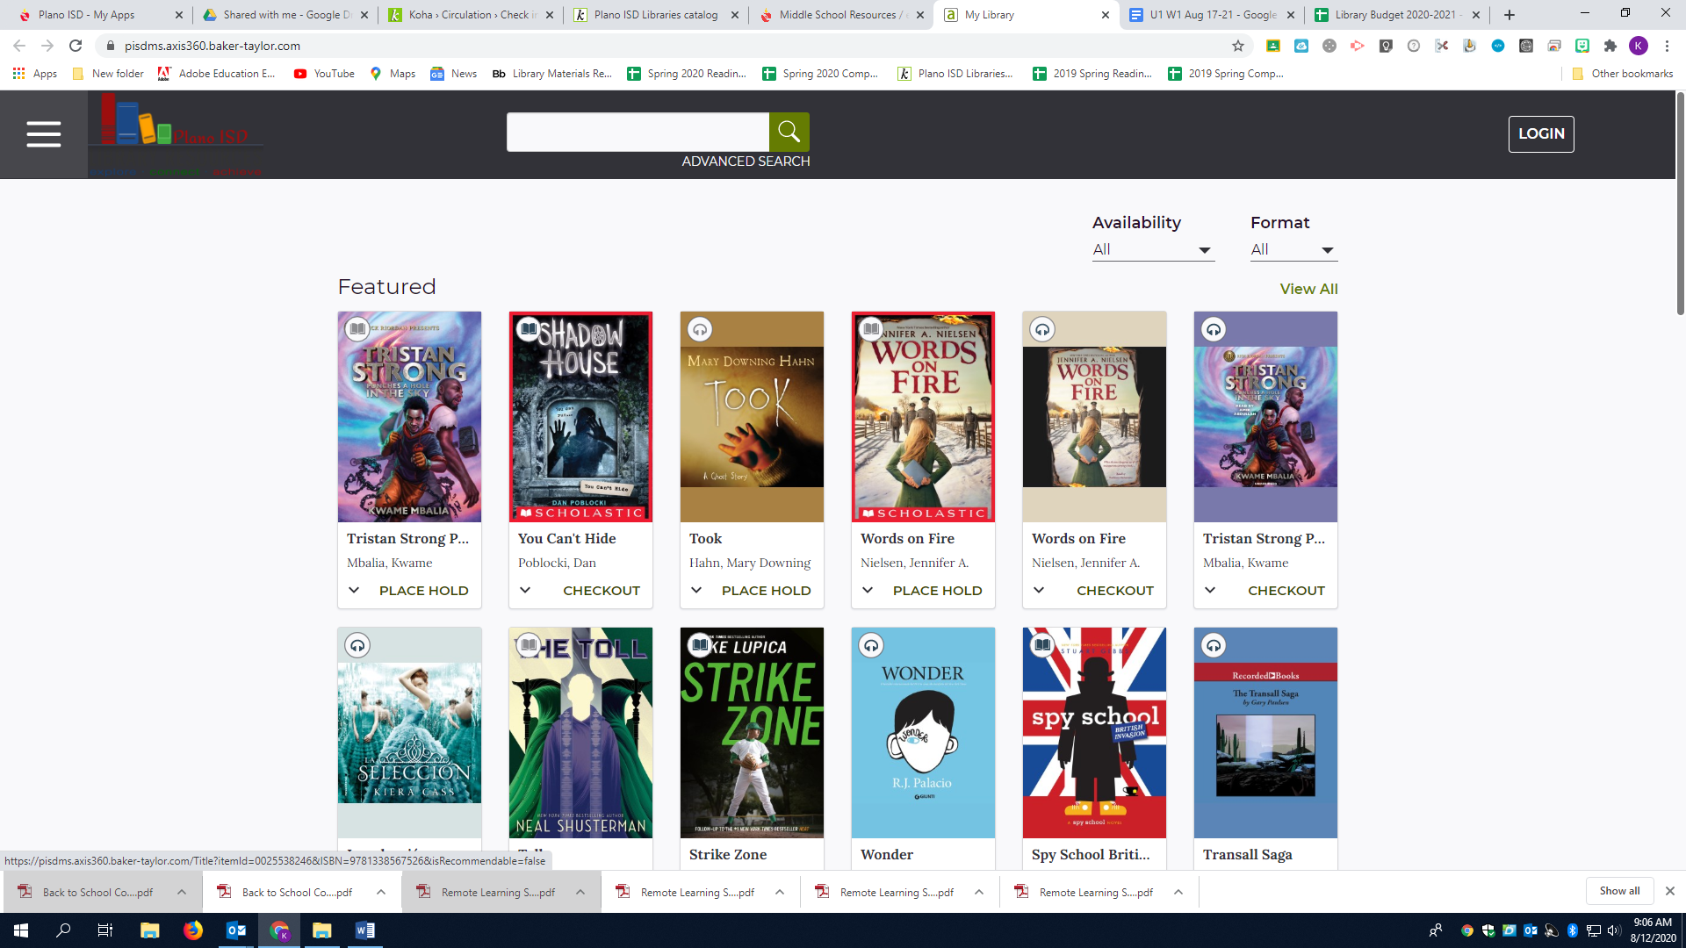

Notice, this has all kinds of books on it. Also, it shows right away Tristan Strong (green arrow) is grayed out and it has a book icon, it is an ebook, that is already checked out by someone, but I could place a hold. You would click on the “Place Hold” button. Here is Shadow House (green arrow) that is dark gray, and it has a “Checkout” button. This one would be available for checkout. Take a look at Took (green arrow). It has headphones. That tells me it is only an audio book. Some books have both the eBook and Audiobook available, like Tristan Strong. So you choose what to read and how you want to experience your book.

You may check out ONE (1) eBook or Audio book at a time. The time you can have it checked out is 3 WEEKS. When you try to checkout or read your book for the first time each computer session, it will ask you to login.

LOG IN:

The Library Card ID is your computer username, and the PIN is your computer password.

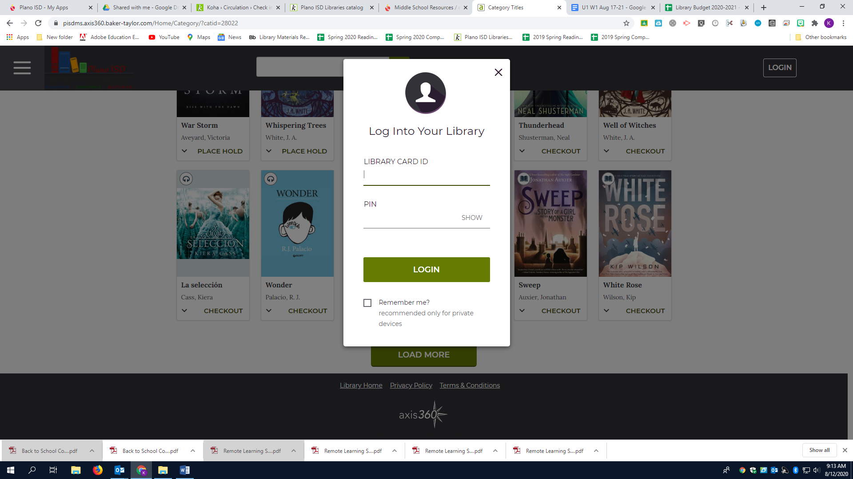

When you are searching you can choose only ebooks or only audio books. You can also choose “Available Now”. One reason why you might not want to do that is if you want to place a hold on a book, but for showing you guys I am going to click on “Available Now” (see below).

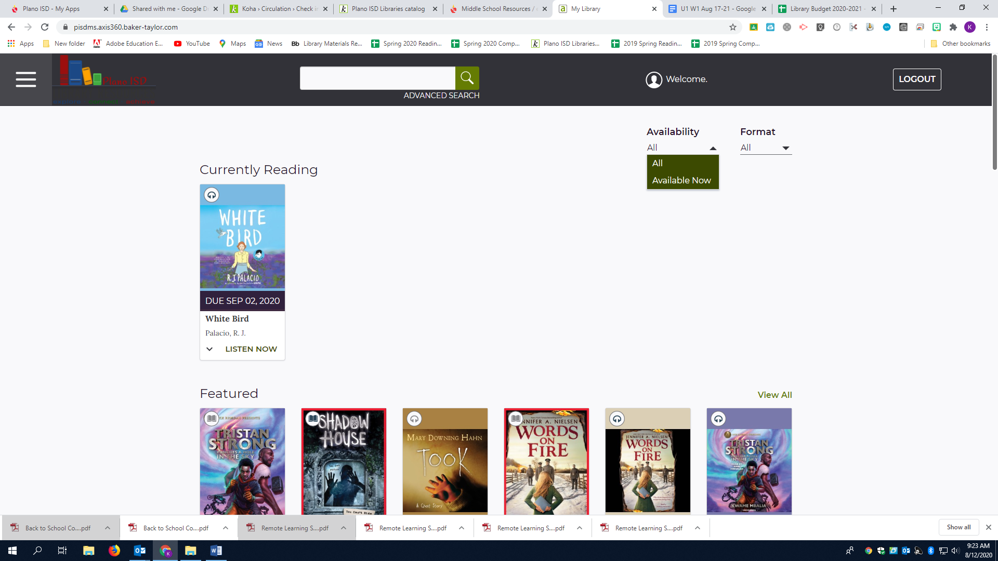

All of the results then are available for check out.
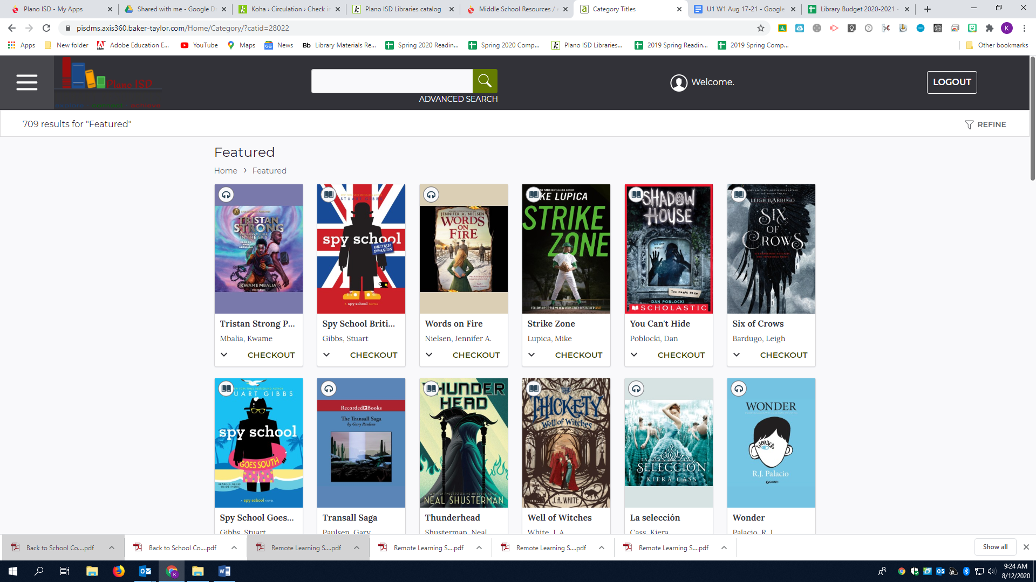

When I place a book on hold, it will ask for my email address. That needs to be your Plano ISD email, which should now work, and you will receive an email when it is available for checkout.
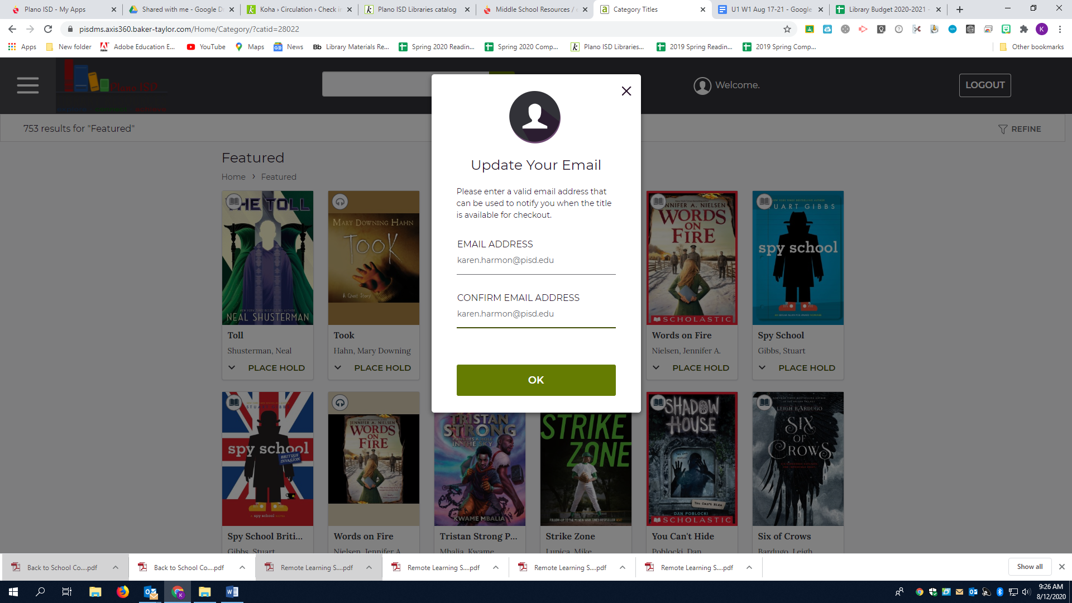

Use the pancake stack on the top left to look at Your library. You will see I have a book checked out, a book on hold, and I have a wishlist.

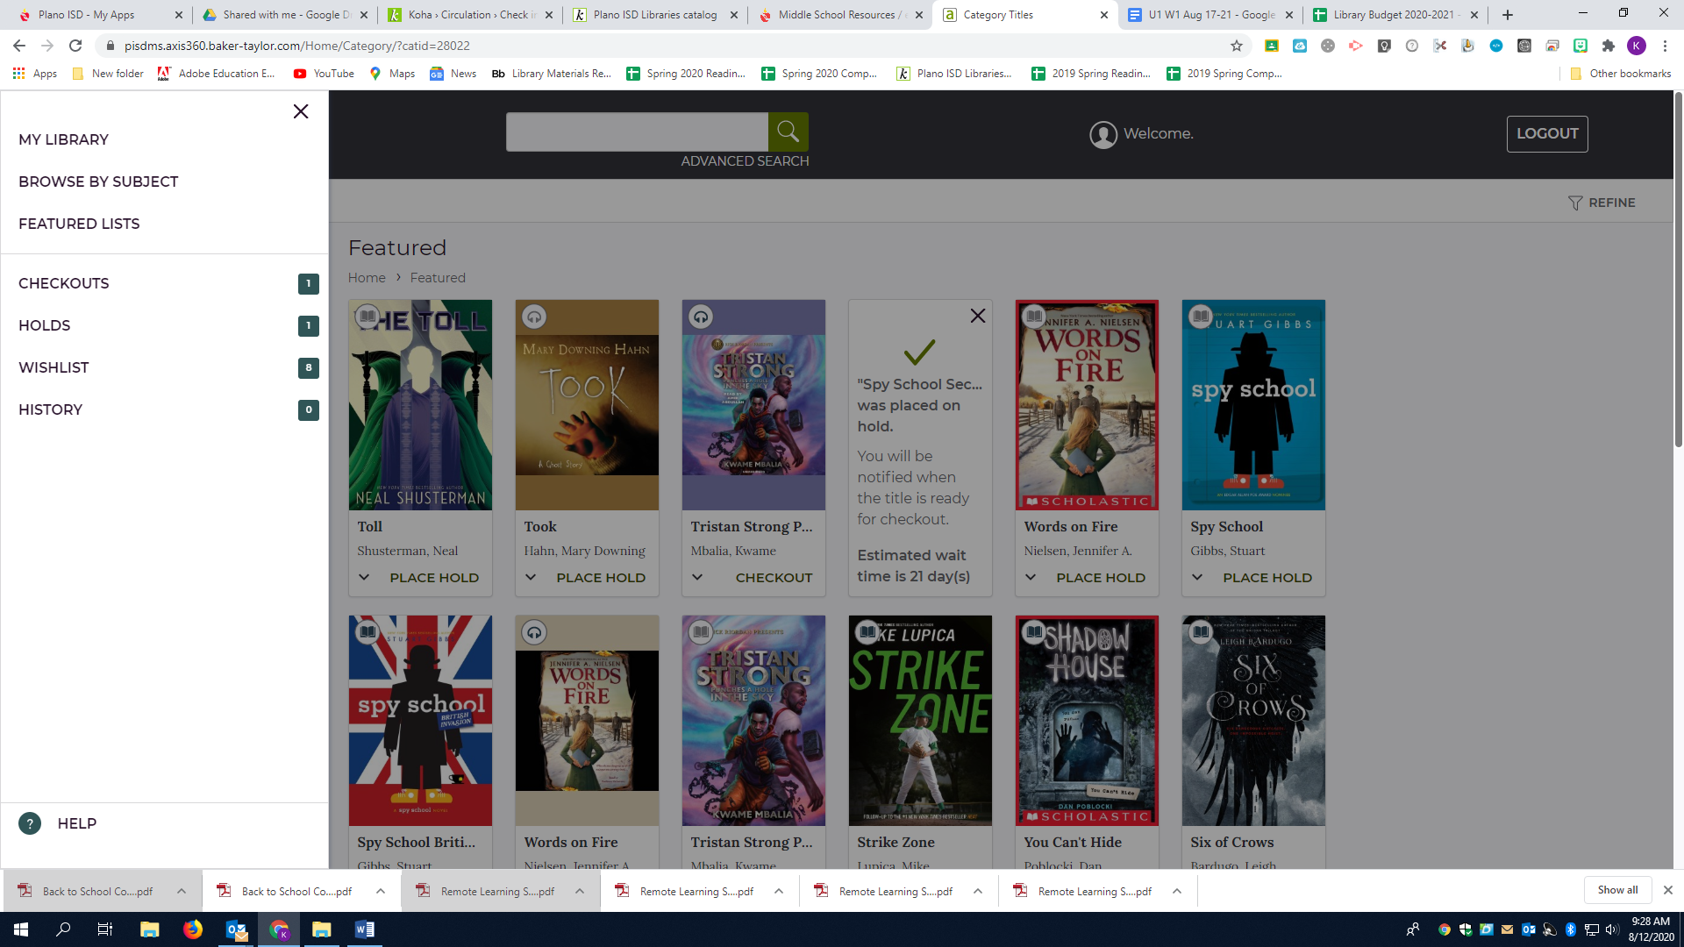

So far we have browsed the eBooks and Audio books that are in the library. You can also search for books by title or author by putting your request in the search bar (see below).

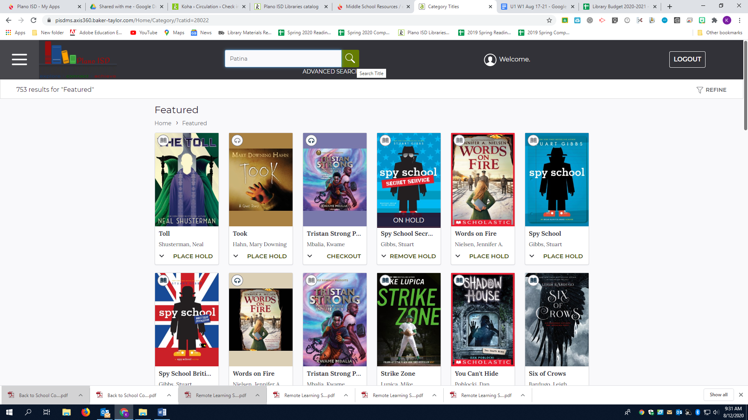

Advanced search:
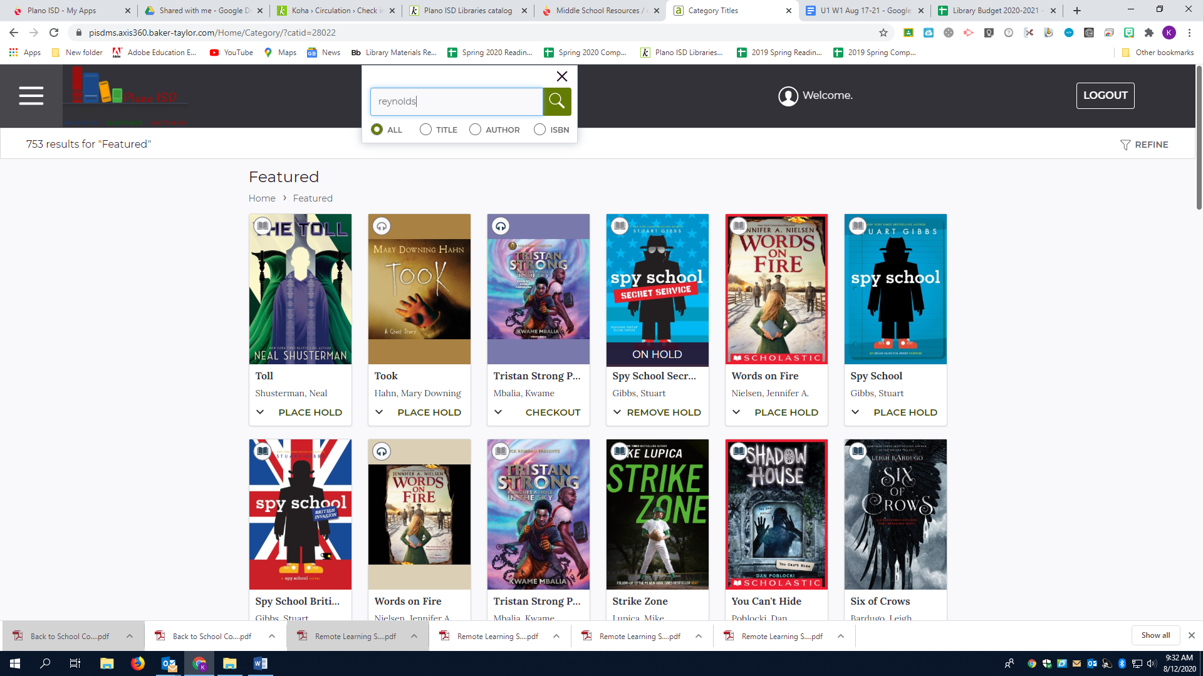

Results from my advanced search using “Reynolds” as my search term:
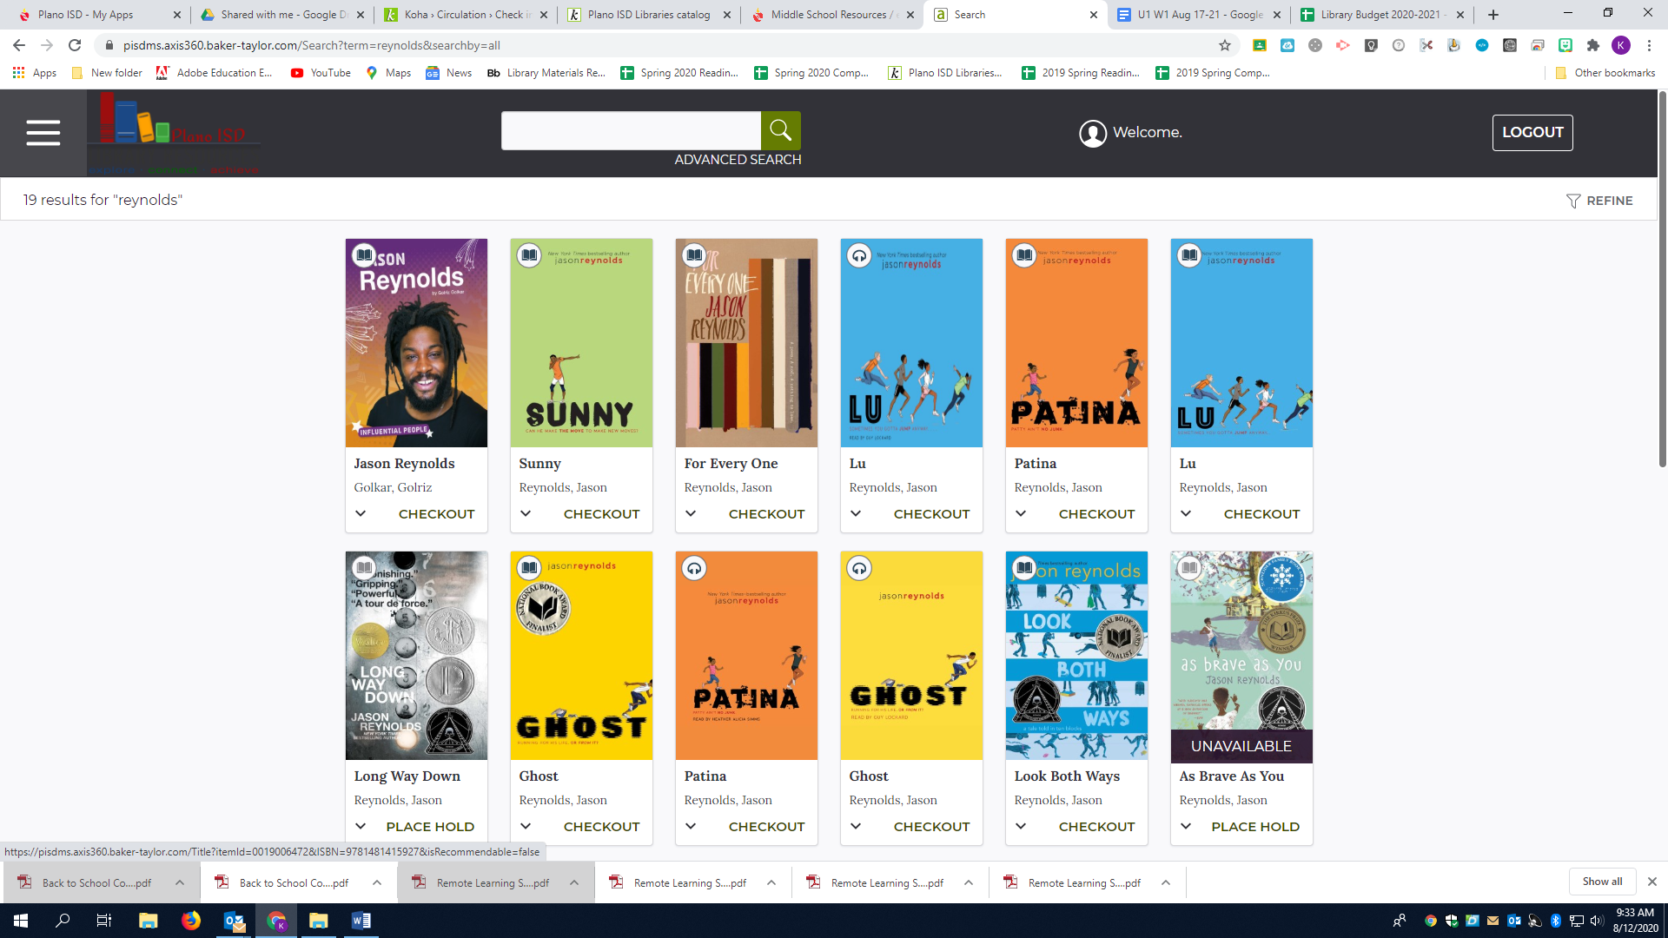

That is it! Have fun checking out ebooks.

Questions? Email me at karen.harmon@pisd.edu

